Part 1

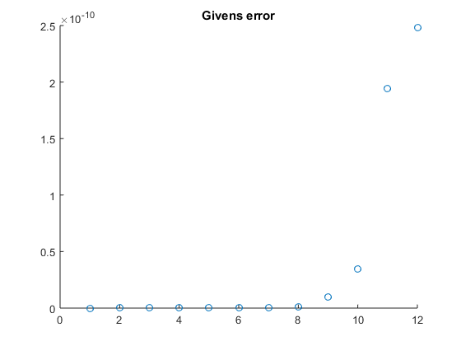

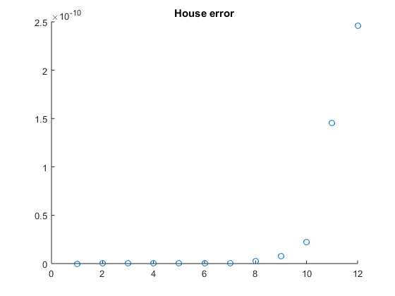

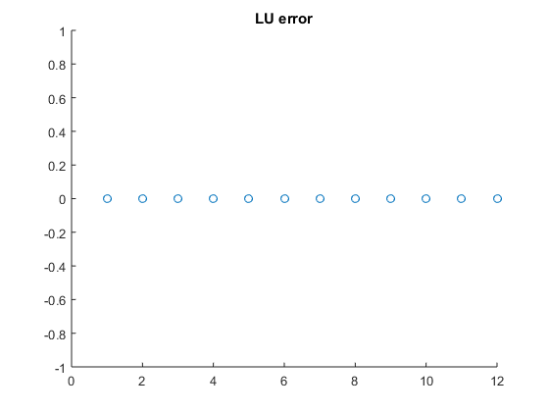

(e) Summarize your findings by plotting the errors obtained as a function of n, for each

of the methods. The plot can be done using your own code, Excel, or any graphing

program. The plots should be included in the written component of this part of the

project.

i. For the expression Ax = b, factoring matrix A takes O(n3). A needs to only be factored once, then can be solved in O(n2) time (the forward and backwards substitution take O(n2) time) which is better than the time to execute x = b\*A-1. Another added benefit of using LU and QR factorization over solving with inverse is that it saves more memory. For example, if n is a giant number, the space to save A would be big itself, but storing A-1 would be exponentially as much.

ii In A = QR, the cond(A) = cond(R) and cond(Q) = 1, because Q is an orthogonal matrix. As a result no new error gets added during computation. LU is easier to compute but does not lend any such advantage per se.